**Part 5 – Factoring Additional Examples**

**Question.** Which of these expressions DOES NOT factor?



A.



B.



C.



D.



E.

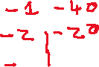

**Extra Example.** Factor

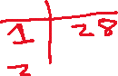

**Extra Example.** Factor

